Strings in JAVA

In Java, string is basically an object that represents sequence of char values. An array of characters works as a string in Java.
The Java String is immutable which means it cannot be changed. Whenever we change any string, a new instance is created. For mutable strings, you can use StringBuffer and StringBuilder classes.
The java.lang.String class implements Serializable, Comparable and CharSequence interfaces.
The CharSequence interface is used to represent the sequence of characters. String, StringBuffer and StringBuilder classes implement it. It means, we can create strings in Java by using these three classes.
There are two ways to create String object:

1. By string literal
2. By new keyword

- Creating String Using String Literal
Each time you create a string literal, the JVM checks the "string constant pool" first. If the string already exists in the pool, a reference to the pooled instance is returned. If the string doesn't exist in the pool, a new string instance is created and placed in the pool. For example:
String s1="Welcome";
String s2="Welcome";//It doesn't create a new instance

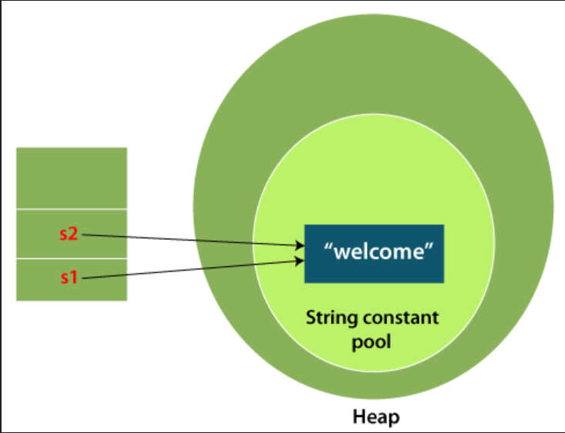

- Creating String Using new Keyword

A string can be created using the new keyword, which explicitly creates a new String object in memory rather than using the string literal pool.

For example:
String s=new String("Welcome"); //creates two objects and one reference variable
Here,
1. "Welcome" is a string literal, so it is stored in the string pool (one object).
2. new String("Welcome") creates a new String object in the heap (second object).
3. s is the reference variable that points to the object in the heap.

In such case, JVM will create a new string object in normal (non-pool) heap memory, and the literal "Welcome" will be placed in the string constant pool. The variable s will refer to the object in a heap (non-pool).

String methods in Java
1. length ()
- Returns the number of characters in a String.
- The return type is int.
- It is commonly used to determine String size.
2. charAt(int index)
- Returns the character at the specified index.
- Indexing starts from 0.
- Throws an exception if the index is outside the valid range.
3. equals(String anotherString)
- Compares two Strings based on their contents.
- Returns true when both Strings contain the same characters.
- The comparison is case-sensitive.
4. equalsIgnoreCase(String anotherString)
- Compares two Strings while ignoring uppercase and lowercase differences.
- Returns true when their contents are equal without considering case.
- It is useful for case-insensitive String comparison.
5. substring(int beginIndex)
- Extracts a portion of a String from the specified index to the end.
- The starting index is inclusive.
- It returns a new String.
6. substring(int beginIndex, int endIndex)
- Extracts characters between the specified beginning and ending indexes.
- The beginning index is inclusive and the ending index is exclusive.
- It returns the selected portion as a new String.
7. indexOf()
- Searches for the first occurrence of a character or substring.
- Returns the index where the match is found.
- Returns -1 when the specified character or substring is not found.
8. lastIndexOf()
- Searches for the last occurrence of a character or substring.
- Returns the index of the last matching occurrence.
- Returns -1 when no match is found.
9. contains(CharSequence sequence)
- Checks whether a specified sequence exists inside the String.
- Returns true if the sequence is present.
- The comparison is case-sensitive.
10. replace()
- Replaces characters or character sequences within a String.
- It performs literal replacement rather than regular-expression matching.
- Returns a new String because Strings are immutable.
11. replaceAll(String regex, String replacement)
- Replaces all portions of a String that match a regular expression.
- The first argument is treated as a regular expression.
- Returns a new String containing the replacements.
12. split(String regex)
- Divides a String into multiple parts based on a regular expression.
- Returns the result as a String[] array.
- It is commonly used for parsing String data.
13. trim()
- Removes leading and trailing characters with code points up to U+0020.
- It does not remove all types of Unicode whitespace.
- It returns a new String when trimming is necessary.
14. toUpperCase() / toLowerCase()
- Converts the characters of a String to uppercase or lowercase.
- The original String is not modified because Strings are immutable.
- These methods are commonly used for normalization and case conversion.
15. compareTo(String anotherString)
- Compares two Strings lexicographically.
- Returns 0 if they are equal, a negative value if the first String is smaller, and a positive value if it is larger.
- The comparison is case-sensitive.

StringBuffer:
The StringBuffer class in Java is used to create mutable (modifiable) string objects. Unlike standard Java strings, which are immutable, the content of a StringBuffer can be changed after it is created. A key characteristic of StringBuffer is that it is thread-safe, meaning multiple threads cannot access it simultaneously, ensuring safe and ordered execution.
Uses of StringBuffer:
- Mutability: It allows you to modify strings (e.g., adding, removing, or replacing characters) without constantly creating new string objects in memory.
- Thread Safety: Its core modification methods are synchronized. This makes it safe to use in multi-threaded environments where multiple threads might attempt to modify the same string resource.

You can instantiate a StringBuffer using three primary constructors:
- StringBuffer(): Creates an empty buffer with a default initial capacity of 16 characters.
- StringBuffer(String str): Creates a buffer initialized with the specified string.
- StringBuffer(int capacity): Creates an empty buffer with a custom specified initial capacity.
Once created, you can modify and interact with the buffer using its synchronized methods:
- append(String s): Concatenates a string to the end of the existing buffer.
- insert(int offset, String s): Inserts a string at a specified position.
- replace(int startIndex, int endIndex, String str): Replaces a range of characters with a new string.
- delete(int startIndex, int endIndex): Deletes characters in a specified range.
- reverse(): Reverses the sequence of characters in the buffer.

Simple Example
Here is a basic example showing how to create a StringBuffer and modify it using the append() method:
class Main {
public static void main(String args[]){
// Create a StringBuffer object with initial content
StringBuffer sb = new StringBuffer("Hello ");

// Append another string to the existing buffer
sb.append("Java"); // The original string buffer is modified directly

// Print the modified result
System.out.println(sb); // Prints: Hello Java
}
}

.

In this example, the string "Hello " is initially stored. Instead of creating a brand-new string object during concatenation, the append() method directly modifies the existing buffer to output "Hello Java".

StringBuilder:
The StringBuilder class in Java, which belongs to the java.lang package, represents a mutable (modifiable) sequence of characters.
It provides an API that is fully compatible with StringBuffer but carries no guarantee of synchronization. Because it is non-synchronized (not thread-safe), it functions as a highly efficient, high-performance alternative for creating and modifying strings in single-threaded environments.

Here are the key properties of the StringBuilder class as detailed in your sources:
- Mutability: It represents a mutable sequence of characters. This means the content of the string (its character sequence) can be modified, added, removed, or replaced in-place without creating a brand-new object in memory.
- Non-Synchronized (Not Thread-Safe): The class offers no guarantee of synchronization. Multiple threads can call the methods of a StringBuilder instance simultaneously, making it unsafe for multi-threaded operations.
- High Performance and Speed: Because its operations do not carry the overhead of synchronization, it operates with maximum efficiency and speed during frequent string modifications.

The primary disadvantage of the StringBuilder class is:
- Not Thread-Safe (Non-Synchronized): StringBuilder does not offer any guarantee of synchronization. Because it is non-synchronized, multiple threads can call its methods simultaneously. This means it is not safe for use in multi-threaded environments, where concurrent modifications to the same StringBuilder instance can lead to data inconsistency or errors.
If thread safety is absolutely compulsory for your application, you cannot use StringBuilder and must use StringBuffer instead.

Object-Oriented Programming
Object-Oriented Programming (OOP) is a programming paradigm based on the concept of objects that contain data (fields) and behaviour (methods). It focuses on designing software that closely represents real-world entities.
It is used to Improves code reusability, enhances maintainability and scalability, makes programs easier to understand and manage, closely models real-world entities.
What is state?
- State is anything which has values and attributes together.
- State = attributes + values
- State means giving values to attributes.
What is behaviour?
- Response given by object to outside world.
- Behaviour represents the actions or operations that an object can perform.
- Behaviour tells us what an object can do.
What is Identity?
Identity is the unique characteristic that distinguishes one object from another object, even if both objects have the same state or data.
What is responsibility?
- Role of an object in a program.
What is class?
- A class is a blueprint or template used to create objects in Object-Oriented Programming.
- Class is a way of implementing encapsulation.
- A class is a user-defined data type that contains variables (data) and methods (functions) to operate on that data.
What is object?
- An object is a runtime instance of a class that has its own state and behaviour.
- Object is something which has state, behaviour, identity and responsibility.
Why do we use OOP in Java?
- We use OOP to organize software around objects so that the code becomes reusable, maintainable, secure, scalable, and easier to understand.
* We need to follow some steps to make a program to object oriented:
- Encapsulation
- Inheritance
- Polymorphism
- Abstraction

1) Abstraction
What is abstraction?
It is a process of selective ignorance.
Abstraction in Java means hiding internal implementation details and showing only the essential features of an object.
How it is achieved:
- Abstract class (using abstract keyword)
- Interface
Abstract
The abstract keyword in Java is used to declare a class or a method that is incomplete and must be implemented by subclasses.
Key points:
- An abstract class cannot be instantiated (no object can be created).
- An abstract method has no body (only declaration).
- Subclasses must override abstract methods.

Interface
- Interface provide is-like-a relation.
- In Interface all functions are public and abstract by default, that's why it is known as "pure abstract class".
- To maintain is like a relationship, Java has given keyword "implements" with interface.
Interface is used for following reasons:
- Interface provides is-like-a relationship.
- Interface provides an unbreakable contract between interface and class.
- Provide flexibility and multi-type compatibility.
- Connect totally different hierarchies.

2) Encapsulation
What is encapsulation?
- It is a process of binding and hiding of state and behaviour of a object by default.
What is class?
- Class is a way of implementing encapsulation.
Why to bind state and behaviour?
- Because in real life inseparable. Ex. Fan and air is not separate.
Why to hide state and behaviour?
- Because in real life behaviour is hidden by default.
3) Inheritance
What is inheritance?
- Inheritance is a way of reusing already defined class with is-a relationship / encapsulation state and behaviour with is-a relationship.
Why should we perform inheritance?
- Because through inheritance, we can achieve and reuse [and] can avoid redundancy.

In Java, inheritance is classified into the following types:
1. Single Inheritance
One class inherits from one parent class.
Example: B extends A
2. Multilevel Inheritance
A class inherits from another class, which itself inherits from another.
Example: C extends B, B extends A
3. Hierarchical Inheritance
Multiple classes inherit from the same parent class.
Example: B extends A, C extends A
4. Hybrid Inheritance (Not directly supported)
Combination of two or more types of inheritance.
👉 Achieved using interfaces in Java.

👉 In short:
Java supports Single, Multilevel, Hierarchical, and allows Multiple/Hybrid using interfaces only.

4) Polymorphism
What is polymorphism?
- Same message given to generalised things for same behaviour but implemented differently.
- Polymorphism is the ability of a method or object to take many forms, allowing the same method name to perform different tasks.

Function Overloading
- In function overloading function signature is considered in which function name must be same and parameter list must be different as follows:
      - Number of parameters must be different.
- Data type of parameter must be different.
- Sequence of data type of parameter must be different.
- For function overloading "name mangling" happens at compile time. In Java it is "name descriptor".
What is name mangling?
- Name mangling is a process of changing the name of overloaded function at compile time using the rule of function overloading.
- Name mangling is done by compiler.
- In Java name mangling kind of process is implemented through descriptors.
- Descriptor usually change the name of function by using combination of package name, class name, function name, parameter list and many other things if needed.

Overriding
- Method Overriding in Java means a subclass provides its own implementation of a method that is already defined in the parent class.
- True polymorphism
- In this method declaration or prototype is consider.
- Runtime polymorphism
- Late binding: Late binding is the process where the method to be executed is determined at runtime based on the object type.

class Animal {
void sound() {
System.out.println("Animal sound");
}
}
class Dog extends Animal {
void sound() {
System.out.println("Dog barks");
}
}
public class Main {
public static void main(String[] args) {
Animal a = new Dog(); // parent reference, child object
a.sound(); // decided at runtime
}
}

Constructor
A constructor is a special member of a class that is automatically invoked when an object of that class is created. It is primarily used to initialize the object's state.
Constructor name must be the same as the class name.
It does not have a return type, not even void.
It is called automatically when we create an object using new.
It is mainly used to initialize instance variables.
A class can have multiple constructors with different parameter lists (constructor overloading).
Types of Constructors
- Default Constructor
  - Does not take any parameters.
  - Initializes the object with default values.
- Parameterized Constructor
A parameterized constructor:
  - Takes arguments.
  - Initializes the object with specific values.
  - Allows passing values at the time of object creation.
  - Helps in directly initializing data members.

Encapsulation
- It is a process of binding and hiding of state and behaviour of an object by default.
- In Java, encapsulation is mainly achieved by declaring variables as private and providing public getter and setter methods to access and modify them.
- For example, if we have a Student class, we can make the student's name private and provide a getName() method to read it and a setName() method to change it.
- The main advantage of encapsulation is data security and controlled access. It prevents other classes from directly changing important data and allows us to add validation before modifying it.
- So, in simple words, encapsulation means hiding the internal data of a class and providing controlled access through methods. It improves security, maintainability, and flexibility of Java programs.
class Student {
// Private variables
private String name;
private int age;

// Setter methods
public void setName(String name) {
this.name = name;
}

public void setAge(int age) {
this.age = age;
}

// Getter methods
public String getName() {
return name;
}

public int getAge() {
return age;
}
}

public class Main {
public static void main(String[] args) {
Student s = new Student();
s.setName("Dhiraj");
s.setAge(22);
System.out.println(s.getName());
System.out.println(s.getAge());
}
}

Advantages
- Data Protection: It stops outside code from directly accessing or changing your variables, ensuring your data remains safe and correct.
- Better Security: By hiding the inner workings of your class and only showing what is absolutely necessary, it protects sensitive data from mistakes and misuse.

Inheritance
Inheritance is the way of reusing already defined classes with “is-a” relationship. In inheritance when we create subclass’s object then object of super class gets created implicitly. In java “extends” keyword is used to established “is-a” relationship. In java we can extend only one class [no multiple inheritance allowed in java]
The inheritance is used for the following important reasons:
- Method Overriding: Inheritance allows a subclass to provide a specific implementation of a method already defined in its superclass. This is also known as runtime polymorphism.
- Code Reusability: Inheritance allows developers to reuse the existing code from a parent class which reduces the redundancy and makes the code easier to maintain.
Types of Inheritance
There are several types of inheritance supported in Java:
- Single Inheritance:
Single inheritance allows a subclass inherits from one superclass only.
- Multilevel Inheritance:
Multilevel inheritance allows a class is derived from a subclass, forming a chain of inheritance.
- Hierarchical Inheritance:
Hierarchical inheritance allows multiple subclasses inherit from the same superclass.
- Hybrid Inheritance (Through Interfaces):
Hybrid inheritance combines two or more types of inheritance using interfaces to avoid multiple inheritance issues.

Polymorphism
- Same message given to generalized thing for same behaviour but implemented differently.
- In java polymorphism allows the same method name to perform different actions based on the object that calls it.
- True polymorphism in java is implemented through function overriding.
Types of Polymorphism in Java
Java mainly supports two types:
- Compile-Time Polymorphism (Method Overloading)
- Runtime Polymorphism (Method Overriding)

Compile-Time Polymorphism
- In java compile-time polymorphism is achieved using method overloading.
- In function overloading function signature is consider in which function name must be same and parameter list must be different as follows:
- number of parameters must be different
- Data type of parameter must be different
- Sequence of data type of parameter must be different
- In method overloading, methods must have the same name but must differ in the number or data types of parameters. When a method is called, the compiler selects the most suitable overloaded method based on the arguments provided. If an exact match is found, that method is invoked; otherwise, the compiler applies type promotion to find the closest matching method.
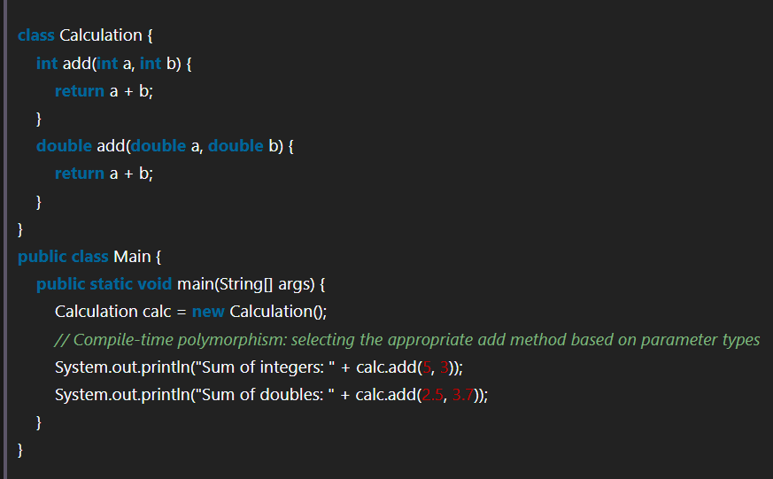
- For function overloading "name mangling" happens at compile time in java it is "name & descriptor".
what is name mangling?
$→$ name mangling is a process of changing the name of overloaded function at compile time using the rule of function overloading
- Name mangling is done by compiler
- In java name mangling kind of process is implemented through descriptors
- Descriptor usually change the name of function by using combination of package name, class name, function name, parameter list and many other things if needed

Runtime Polymorphism
- In java Runtime Polymorphism is achieved by using Method Overriding.
- It is also called as true polymorphism.
- In this same message is given to the generalise things but implemented differently.
- In these methods is already defined inside super class and it is override base class. Where we provide different implementation for this method.
- It is also known as dynamic binding, late binding, or dynamic method dispatch.

How to implement function overriding?
$→$ There are two steps in function overriding:
- Write / define / declare a function in super class.
- Define a same function in subclass with different implementation.
(Here same mean the declaration / prototype of function must match)

Abstraction
It is a process of selective ignorance.
Abstraction in Java means hiding internal implementation details and showing only the essential features of an object.
In simple words, abstraction means showing what an object can do and hiding how it does it.
When we use a system, we usually do not need to know all the internal operations performed by that system. We only need to know the functionality that is available to us.

Why do we need abstraction:
We use abstraction to hide the complexity of a system and provide a simple way to interact with it. We use abstraction to hide the complexity of a system and provide a simple way to interact with it. A real-world software application can contain thousands of lines of code and many complex operations. If all these implementation details were exposed to the user, the system would become difficult to understand and use. Abstraction allows us to expose only the functionality that is necessary for the user.
Real life example:
When a driver presses the brake, the driver knows that the car should slow down or stop. The driver does not need to know all the internal mechanical and electronic processes involved in braking. The driver interacts with the functionality without knowing its complete implementation.

In Java, abstraction is mainly achieved using abstract classes and interfaces. An abstract class is declared using the abstract keyword.
Abstract classes can contain abstract as well as concrete methods, while interfaces are primarily used to define a contract that implementing classes must follow.

Difference between abstraction and encapsulation
Abstraction and encapsulation are both important OOP concepts, but they solve different problems.
Abstraction focuses on hiding implementation complexity, whereas encapsulation focuses on bundling data and methods together and controlling access to that data.

Abstract class
An abstract class is a class that is declared using the abstract keyword and is intended to serve as a base class for other classes rather than being instantiated directly.
An abstract class is useful when we want to define some common state and behavior for a group of related classes, while leaving certain behavior for the subclasses to implement.

Properties of an Abstract Class
- An abstract class is declared using the abstract keyword.
- An abstract class cannot be instantiated directly.
- An abstract class can contain abstract methods.
- An abstract class can contain concrete methods.
- It is not mandatory that abstract class does not have to contain an abstract method.

What is abstract function?
Abstract function is such a function for which only declaration exist but definition/body does not. It is said that abstract classes are must be inherited and abstract function must be overridden. If we do not override abstract function in sub class it is inherited as abstract function and then sub class too becomes abstract.

Collection Framework
Collection framework
- A Collection Framework is a set of classes and interfaces used to store and manage groups of objects in Java.
- It provides ready-made data structures such as List, Set, Queue, and Map.
- It helps programmers perform operations like adding, removing, searching, and sorting data easily.
- The Java Collection Framework makes data handling efficient, organized, and reusable.
Collection vs Collections
- Collection
Collection is an interface present in java.util package. It is used to represent a group of individual objects as a single unit.
The collection is considered as the root interface of the collection framework.
It provides several classes and interfaces to represent a group of individual objects as a single unit.
The List, Set, and Queue are the main sub-interfaces of the collection interface. The map interface is also part of the java collection framework, but it doesn't inherit the collection of the interface.

Following are Collection interface methods:

Collection Interface Methods and Their Uses
- add(E e) – Adds an element to the collection.
- addAll(Collection c) – Adds all elements of another collection.
- remove(Object o) – Removes the specified element from the collection.
- removeAll(Collection c) – Removes all elements that are present in another collection.
- retainAll(Collection c) – Retains only the elements that are present in another collection.
- clear() – Removes all elements from the collection.
- contains(Object o) – Checks whether the specified element exists in the collection.
- containsAll(Collection c) – Checks whether all elements of another collection are present.
- size() – Returns the number of elements in the collection.
- isEmpty() – Checks whether the collection contains no elements.
- iterator() – Returns an iterator to traverse the elements of the collection.
- toArray() – Converts the collection into an array.
- toArray(T[] a) – Converts the collection into an array of the specified type.
- equals(Object o) – Compares the collection with another object.
- hashCode() – Returns the hash code value of the collection.
- stream() – Returns a sequential stream for processing the elements.
- parallelStream() – Returns a parallel stream for processing the elements.
- removeIf(Predicate p) – Removes elements that satisfy the given condition.
- spliterator() – Returns a Spliterator for traversing and processing elements.

- Collections

Collections is a utility class present in java.util package. It defines several utility methods like sorting and searching which is used to operate on collection. It has all static methods. These methods provide much-needed convenience to developers, allowing them to effectively work with Collection Framework. For example, It has a method sort() to sort the collection elements according to default sorting order, and it has a method min(), and max() to find the minimum and maximum value respectively in the collection elements.

Collections Class Methods and Their Uses
The Collections class is a utility class in Java that provides static methods for operating on collections such as List, Set, and other collection types.
- sort(List<T> list) – Sorts the elements of a list in ascending order.
- sort(List<T> list, Comparator c) – Sorts the list according to the specified comparator.
- reverse(List<?> list) – Reverses the order of elements in a list.
- shuffle(List<?> list) – Randomly rearranges the elements of a list.
- swap(List<?> list, int i, int j) – Swaps two elements at the specified positions.
- max(Collection c) – Returns the largest element in a collection.
- min(Collection c) – Returns the smallest element in a collection.
- frequency(Collection c, Object o) – Returns the number of times an element occurs in a collection.
- binarySearch(List<? extends Comparable> list, T key) – Searches for an element in a sorted list using binary search.
- fill(List<? super T> list, T obj) – Replaces all elements of a list with the specified element.
- copy(List<? super T> dest, List<? extends T> src) – Copies elements from one list to another.
- replaceAll(List<T> list, T oldVal, T newVal) – Replaces all occurrences of one value with another.
- rotate(List<?> list, int distance) – Rotates the elements of a list by the specified distance.
- reverseOrder() – Returns a comparator that sorts elements in descending order.
- disjoint(Collection<?> c1, Collection<?> c2) – Checks whether two collections have no common elements.
- addAll(Collection<? super T> c, T... elements) – Adds multiple elements to a collection.
- unmodifiableList(List<? extends T> list) – Returns an unmodifiable view of the specified list.
- synchronizedList(List<T> list) – Returns a synchronized (thread-safe) list.
- singletonList(T o) – Returns an immutable list containing only one element.
- emptyList() – Returns an empty immutable list.

Java Collection Hierarchy

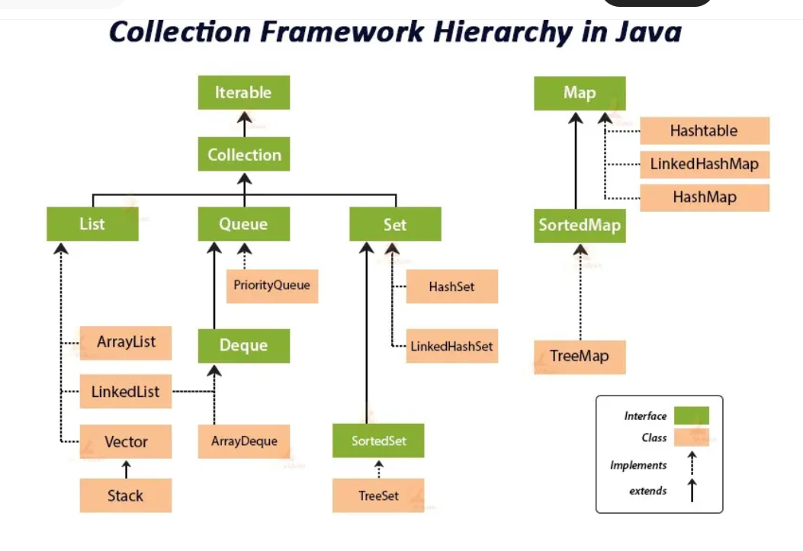

Types of Collections in Java
Java Collection Framework provides different types of interfaces and classes:
Interfaces:
- List
- Set
- Queue
- Deque
Classes:
- ArrayList
- Vector
- LinkedList
- PriorityQueue
- HashSet
- LinkedHashSet
- TreeSet

List interface
List is an interface in the Java Collection Framework that represents an ordered collection of elements. It allows duplicate elements and provides index-based access to elements.
Common implementations are ArrayList, LinkedList, Vector, and Stack.
Properties:
- Maintains Insertion Order: Elements are stored in the order in which they are inserted.
- Allows Duplicate Elements: A List can contain duplicate values.
- Allows Null Values: List implementations generally allow null values.
- Index-Based Access: Elements can be accessed using their index.
IMPORTANT LIST METHODS IN JAVA COLLECTION FRAMEWORK
- add(E e)
  - Adds an element to the list.
  - Example: list.add("Java");
- add(int index, E element)
  - Adds an element at a specific index.
  - Example: list.add(1, "Python");
- addAll(Collection c)
  - Adds all elements of another collection.
  - Example: list.addAll(list2);
- get(int index)
  - Returns the element at the specified index.
  - Example: list.get(0);
- set(int index, E element)
  - Replaces an element at the specified index.
  - Example: list.set(0, "C++");
- remove(int index)
  - Removes the element at the specified index.
  - Example: list.remove(0);
- remove(Object o)
  - Removes the first occurrence of the specified element.
  - Example: list.remove("Java");
- removeAll(Collection c)
  - Removes all elements that are present in another collection.
  - Example: list.removeAll(list2);
- contains(Object o)
  - Checks whether the list contains the specified element.
  - Example: list.contains("Java");
- indexOf(Object o)
  - Returns the index of the first occurrence of an element.
  - Example: list.indexOf("Java");
- lastIndexOf(Object o)
  - Returns the index of the last occurrence of an element.
  - Example: list.lastIndexOf("Java");
- size()
  - Returns the number of elements in the list.
  - Example: list.size();
- isEmpty()
  - Checks whether the list is empty.
  - Example: list.isEmpty();
- clear()
  - Removes all elements from the list.
  - Example: list.clear();
- subList(int fromIndex, int toIndex)
  - Returns a portion of the list.
  - Example: list.subList(1, 3);
- sort(Comparator c)
  - Sorts the elements of the list.
  - Example: list.sort(null);
- Collections.reverse(list)
  - Reverses the order of elements.
  - Example: Collections.reverse(list);

ArrayList
- ArrayList is a resizable-array implementation of the List interface in Java. It maintains insertion order, allows duplicate and null elements, provides index-based random access, and dynamically grows or shrinks as elements are added or removed. It is not synchronized by default.
- Unlike a normal array, whose size is fixed when it is created, an ArrayList can automatically grow or shrink when elements are added or removed.
- The size of an ArrayList is not fixed. It automatically increases when new elements are added and decreases when elements are removed.
- ArrayList maintains the order in which elements are inserted.
- An ArrayList allows multiple occurrences of the same element.

LinkedList
LinkedList is a doubly linked list implementation of the List and Deque interfaces in Java. It belongs to the java.util package.
Unlike ArrayList, which uses a resizable array internally, LinkedList stores elements in nodes, where each node contains the element and references to the previous and next nodes.
Properties of LinkedList in Java
- Doubly Linked List – LinkedList stores elements in nodes, and each node maintains references to the previous and next node.
- Dynamic Size – Its size can increase or decrease automatically when elements are added or removed.
- Maintains Insertion Order – Elements are stored and retrieved according to the order in which they were inserted.
- Allows Duplicates and Null – A LinkedList can contain duplicate elements as well as null values.
- Implements List and Deque – It implements both List and Deque, so it can be used as a list, queue, or deque.
No. | Method | Purpose
1 | add() | Adds an element to the end
2 | addFirst() | Adds an element at the beginning
3 | addLast() | Adds an element at the end
4 | get() | Returns an element at a specified index
5 | getFirst() | Returns the first element
6 | getLast() | Returns the last element
7 | remove() | Removes an element
8 | removeFirst() | Removes the first element
9 | removeLast() | Removes the last element
10 | contains() | Checks whether an element exists

Exception Handling
Exception
In Java, an exception is an event that occurs during the execution of a program and disrupts the normal flow of instructions.
Exception Handling
In java almost all the exceptions execution which happen through method is binded dynamically / Runtime, so java developers were well aware of many Runtime issues which may occurs and disconnect the programming abruptly.
So, they built a very good mechanism known as exception handling framework, which contains multiple classes and methods.
It also provides five keywords as follows:
- try
- catch
- finally
- throw
- throws

- try:
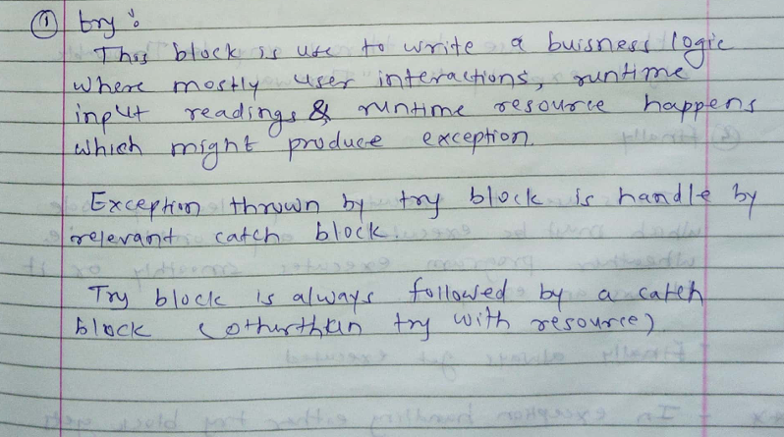

- catch
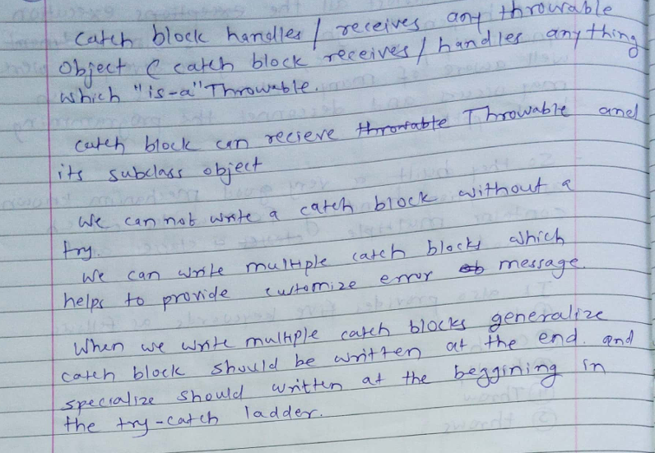

- throw
The throw keyword in Java is used to explicitly throw an exception when a specific condition occurs.
It is used inside the method or code block to manually create and throw an exception object.
Syntax: throw new ExceptionType("message");

- finally
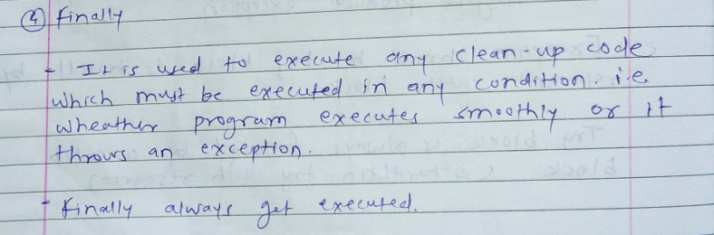
- throws
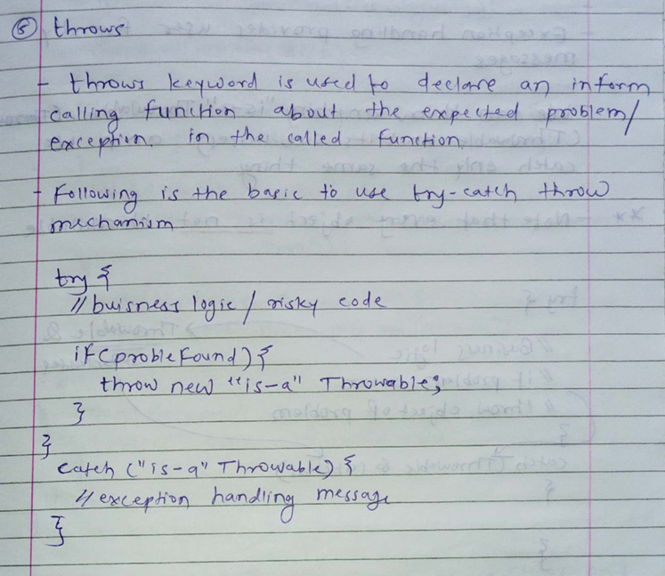

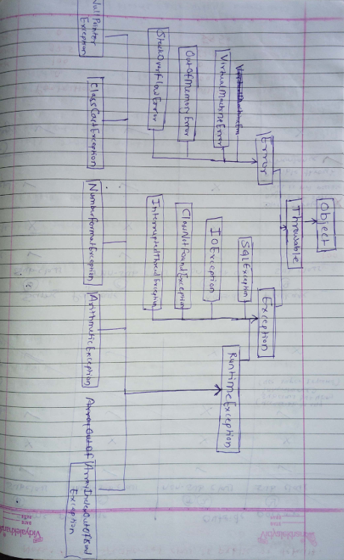
Checked and Unchecked Exception
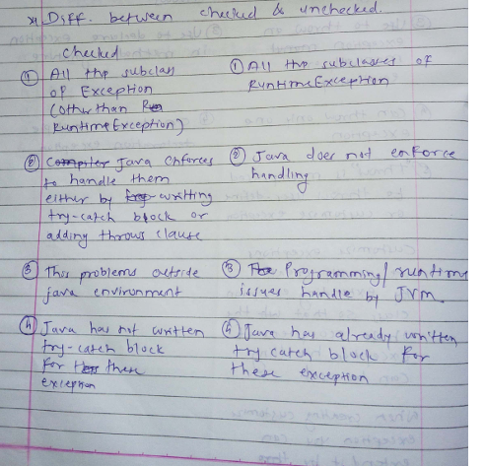

Hierarchy of Java Exception classes
Exceptions are represented by classes, and all exception classes are part of the java.lang package. They are organized in a hierarchical structure with Throwable at the top. The main hierarchy is as follows:
- Throwable: The superclass of all errors and exceptions in Java.
  - Error: Represents serious system errors that applications usually cannot handle (e.g., OutOfMemoryError).
  - Exception: Represents conditions that a program might want to catch.
    - Checked Exceptions: Must be either handled using try-catch or declared using throws (e.g., IOException, SQLException).
    - Unchecked Exceptions (RuntimeException): Do not need explicit handling, typically caused by programming errors (e.g., NullPointerException, ArithmeticException).

